Contents
Terraform End to End Project: 2
1. Architecture of project 2
1.1. Method: 2
2 .Terraform workflow directory 2
3. Creation of vpc and it components in modular approach 3
4. Security-Group 6
5. Instances 7
6. Launch template 9
7. AutoScaling Group 11
8. Load balancer 13
9. userdata for installing all the tools like Jenkins, trivy, sonarqube , docker etc 15
10. Userdata for configuring k8s-master node 16
11. worker userdata 18
12 . main.tf 20
13 . Vpc 26
14 . Instances. 27
15 . CI/CD pipeline using Jenkins 29
15.1. integrating k8s with Jenkins 29
15.2 Integrating Docker with Jenkins 31
15.3. Integrating jenkins sonarqube 32
16. CI/CD pipeline 33
17. Autoscaling group 38
18. Load balancer 39
19. Access chatbot application on Browser 40

Terraform End to End Project:

Architecture of project:
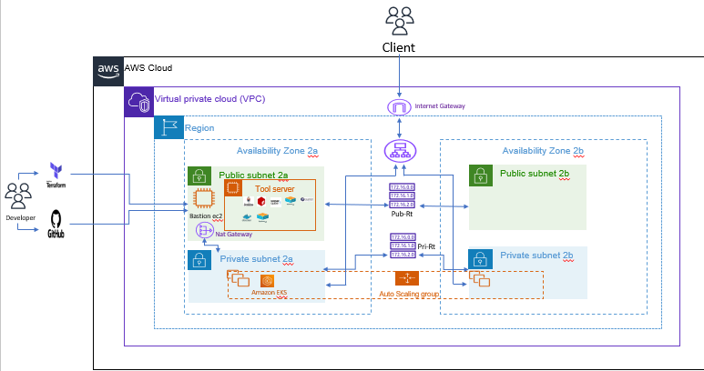

Method:
- Developer pushes the code to Github.
- Using Terraform (IAC) creatingg all the infrastructure required for project
like VPC, public and private subnet, Public and private route tables,
Internet Gateway, Nat Gateway,
- Creatingg One Bastion host and tool server in Public subnet
Bastion for accessing instances present in private subnet and
Tool-server to install tools like Jenkins, Sonarqube, Trivy and Docker etc.
- Configures NAT gateway in public subnet to provide internet access to the resources in private subnet.
- Configure Kubernetes for deploying application in Private subnet for security of application
- Creatingg AutoScalerGroup for high scalability of application
- Creatingg Load balancer for high availability of application
- Using Jenkins as CI/CD tools for deploying application which involves steps
code checkout, code analysis with sonarqube, trivy file scanning, dependency check, build docker images, trivy image scanning , pushing image to dockerhub and deploying application with Kubernetes

2 .Terraform workflow directory
├── vpc
│ ├── main.tf
│ ├── output.tf
│ └── variable.tf
├── SG
│ ├── main.tf
│ ├── output.tf
│ └── variable.tf
├── ec2-instance
│ ├── main.tf
│ ├── output.tf
│ └── variable.tf
├── asg
│ ├── main.tf
│ ├── output.tf
│ └── variable.tf
├── alb
Main.tf
│ ├── output.tf
│ └── variable.tf
├── launch-template
│ ├── main.tf
│ ├── output.tf
│ └── variable.tf
├── .terraform.lock.hcl
├── kube_join.sh
├── main.tf
├── master_userdata.sh
├── worker_userdata.sh
└── userdata.sh

3. Creation of vpc and it components in modular approach
Follow above table
vpc
│ ├── main.tf
│ ├── output.tf
│ └── variable.tf

In main.tf
resource "aws_vpc" "my-vpc" {
cidr_block = var.cidr_block

tags = {
Name = var.Name
Created_BY = var.Created_BY

}
}

resource "aws_subnet" "public-subnet" {
count = length(var.public_subnet_cidrs)
vpc_id = aws_vpc.my-vpc.id
cidr_block = var.public_subnet_cidrs[count.index]
availability_zone = var.availability_zone[count.index]
map_public_ip_on_launch = true

tags = {
Name = "public-subnet-${count.index +1}"
Created_BY = var.Created_BY
}
}

resource "aws_subnet" "private-subnet" {
count = length(var.private_subnet_cidrs)
vpc_id = aws_vpc.my-vpc.id
cidr_block = var.private_subnet_cidrs[count.index]
availability_zone = var.availability_zone[count.index]
map_public_ip_on_launch = false

tags = {
Name = "private-subnet-${count.index +1}"
Created_BY = var.Created_BY
}
}

resource "aws_internet_gateway" "my-IG" {
vpc_id = aws_vpc.my-vpc.id

tags = {
Name = var.Name
Created_BY = var.Created_BY
}
}

resource "aws_eip" "EIP" {
domain = "vpc"
tags = {
Name = var.Name
Created_BY = var.Created_BY
}
}

resource "aws_nat_gateway" "my-NG" {
allocation_id = aws_eip.EIP.id
subnet_id = aws_subnet.public-subnet[0].id

tags = {
Name = var.Name
Created_BY = var.Created_BY
}

# To ensure proper ordering, it is recommended to add an explicit dependency
# on the Internet Gateway for the VPC.
depends_on = [aws_internet_gateway.my-IG]
}

resource "aws_route_table" "public-RT" {
vpc_id = aws_vpc.my-vpc.id

route {
cidr_block = "0.0.0.0/0"
gateway_id = aws_internet_gateway.my-IG.id
}

tags = {
Name = var.public-RT
Created_BY = var.Name
}
}

resource "aws_route_table" "private-RT" {
vpc_id = aws_vpc.my-vpc.id

route {
cidr_block = "0.0.0.0/0"
gateway_id = aws_nat_gateway.my-NG.id
}

tags = {
Name = var.private-RT
Created_BY = var.Name
}
}

resource "aws_route_table_association" "public-association" {
count = length(var.public_subnet_cidrs)
subnet_id = aws_subnet.public-subnet[count.index].id
route_table_id = aws_route_table.public-RT.id
}

resource "aws_route_table_association" "private-association" {
count = length(var.private_subnet_cidrs)
subnet_id = aws_subnet.private-subnet[count.index].id
route_table_id = aws_route_table.private-RT.id
}

resource "aws_eip" "eip-ec2" {
domain = "standard"
tags = {
Name = var.Name
Created_BY = var.Created_BY
}
lifecycle {
prevent_destroy = true
ignore_changes = all
}

}

Here I have created Elastic IP (aws_eip.eip-ec2) to attach to tool-server so that whenever tool-server deleted or created it will have same public-ip
And count to create multiple resources.

Variable.tf
variable "cidr_block" {
type = string

}

variable "Name" {
type = string
}

variable "Created_BY" {
type = string
}

variable "public_subnet_cidrs" {
type = list(string)
}

variable "availability_zone" {
type = list(string)
}

variable "private_subnet_cidrs" {
type = list(string)
}

variable "private-RT" {
type = string
}

variable "public-RT" {
type = string
}

For subnets and availability zone used list(string) because to Multiple subnets and availability zone are required

Output.tf
output "vpc-id" {
value = aws_vpc.my-vpc.id
}

output "public-subnet" {
value = aws_subnet.public-subnet[*].id
}

output "private-subnet" {
value = aws_subnet.private-subnet[*].id
}

output "ec2-eip" {
value = aws_eip.eip-ec2.id
}

To use resource in another module declaring it in output

Security-Group
- SG
- │ ├── main.tf
- │ ├── output.tf
- │ └── variable.tf

Main.tf
resource "aws_security_group" "this" {
name = var.name
description = "Managed by Terraform"
vpc_id = var.vpc_id

dynamic "ingress" {
for_each = var.ingress_rules
content {
from_port = ingress.value.from_port
to_port = ingress.value.to_port
protocol = ingress.value.protocol

// Only add cidr_blocks if defined
cidr_blocks = length(ingress.value.cidr_blocks) > 0 ? ingress.value.cidr_blocks : null

// Only add security_groups if defined
security_groups = length(ingress.value.security_groups) > 0 ? ingress.value.security_groups : null
}
}

dynamic "egress" {
for_each = var.egress_rules
content {
from_port = egress.value.from_port
to_port = egress.value.to_port
protocol = egress.value.protocol

cidr_blocks = length(egress.value.cidr_blocks) > 0 ? egress.value.cidr_blocks : null
security_groups = length(egress.value.security_groups) > 0 ? egress.value.security_groups : null
}
}
}

This security helps to attach either cidr_block or security_groups to resources based reqirements.
Variable.tf
variable "ingress_rules" {
description = "List of ingress rules"
type = list(object({
from_port = number
to_port = number
protocol = string
cidr_blocks = optional(list(string), [])
security_groups = optional(list(string), [])
}))
default = []
}

variable "egress_rules" {
description = "List of egress rules"
type = list(object({
from_port = number
to_port = number
protocol = string
cidr_blocks = optional(list(string), [])
security_groups = optional(list(string), [])
}))
default = []
}

variable "name" {
type = string
}

variable "vpc_id" {
type = string
}

Output.tf
output "this" {
value = aws_security_group.this.id
}

This allows to use security group in another modules

5. Instances
├── ec2-instance
│ ├── main.tf
│ ├── output.tf
│ └── variable.tf

main.tf
resource "aws_instance" "jump-server" {
ami = var.ami
instance_type = var.instance_type
associate_public_ip_address = var.associate_public_ip_address
key_name = var.key_name
availability_zone = var.availability_zone
subnet_id = var.public-subnet
security_groups = [var.SG]
private_ip = var.private_ip != "" ? var.private_ip : null

user_data = (
var.enable_userdata && var.userdata_path != null && var.userdata_path != ""
? var.userdata_path
: null
)

tags = {
Name = var.jump-server
Created_BY = var.Created_BY
}

lifecycle {
prevent_destroy = true
ignore_changes = all
}

}

in this main.tf we are declaring private-ip , userdata path and userdata as a optional
so that we can use them wherver they are required.
Like for k8s-master module we need fixed private-ip so we are declaring private-ip as optional so that it can be only used k8s-master module.
Variable.tf
variable "ami" {
type = string
}

variable "instance_type" {
type = string
}

variable "key_name" {
type = string
}

variable "availability_zone" {
type = string
}

variable "jump-server" {
type = string
}

variable "Created_BY" {
type = string
}

variable "SG" {
type = string
}

variable "public-subnet" {
type = string
}

variable "enable_userdata" {
type = bool
default = false
}

variable "userdata_path" {
description = "Optional path to user data script (if any)"
type = string
default = null
}

variable "associate_public_ip_address" {
type = bool
default = true
}

variable "private_ip" {
description = "Optional private IP for the EC2 instance"
type = string
default = ""

in variable.tf declaring userdata as boolian
so that we can use it whenever there is reqirement of userdata in ec2 modules by true of false

output.tf
output "public-ip" {
value = aws_instance.jump-server.public_ip
}

output "private-ip" {
value = aws_instance.jump-server.private_ip
}

output "instance-id"{
value = aws_instance.jump-server.id
}

6. Launch template
Steps to remember
Create one new empty instance (tester-instance) from which create this image and launch template
And use the userdata of k8s-worker node module in launch template to automatically configure new instance into k8s cluster
├── launch-template
│ ├── main.tf
│ ├── output.tf
│ └── variable.tf

Main.tf
resource "aws_ami_from_instance" "aj-image"{
name = var.ami-name
source_instance_id = var.source_instance_id

tags = {
Name = var.ami-name
Created_BY = var.Created_BY
}
}

resource "aws_launch_template" "my-LT" {
name = var.aws_launch_template
image_id = aws_ami_from_instance.aj-image.id
key_name = var.key_name
instance_type = var.instance_type
network_interfaces {
associate_public_ip_address = false
security_groups = [var.SG]

}
placement {
availability_zone = var.availability_zone
}
user_data = base64encode(file(var.user_data))

depends_on = [ aws_ami_from_instance.aj-image ]

lifecycle {
prevent_destroy = true
ignore_changes = all
}

}

In here I have created image from new instance (tester-instance) from which I am launching template
Userdata has to be in base64encode otherwise errors will come.
Public-ip is FALSE because using it for creating instance in private subnet.
Variable.tf
variable "ami-name" {
type = string
}

variable "source_instance_id" {
type = string
}

variable "Created_BY" {
type = string
}

variable "aws_launch_template" {
type = string
}

variable "key_name" {
type = string
}

variable "instance_type" {
type = string
}
variable "SG" {
type = string
}

variable "availability_zone" {
type = string
}

variable "user_data" {
type = string
}

Output.tf
output "ami" {
value = aws_ami_from_instance.aj-image.id
}

output "launch_template" {
value = aws_launch_template.my-LT.id
}

7. AutoScaling Group
Creatingg ASG by using above launch template.
├── asg
│ ├── main.tf
│ ├── output.tf
│ └── variable.tf

Main.tf
resource "aws_autoscaling_group" "ASG" {
name = var.asg-name
max_size = var.max_size
min_size = var.min_size
health_check_grace_period = var.health_check_grace_period
health_check_type = var.health_check_type
desired_capacity = var.desired_capacity
force_delete = var.force_delete
vpc_zone_identifier = var.vpc_zone_identifier
target_group_arns = var.target_group_arn
launch_template {
id = var.launch_template
version = "$Latest"
}

tag {
key = "Created_BY"
value = "ajay"
propagate_at_launch = true
}

timeouts {
delete = "15m"
}

tag {
key = "Created_BY"
value = "ajay"
propagate_at_launch = false
}
tag {
key = "Name"
value = "ASG"
propagate_at_launch = false
}

lifecycle {
prevent_destroy = true
ignore_changes = all
}

}

resource "aws_autoscaling_policy" "example" {
autoscaling_group_name = aws_autoscaling_group.ASG.name
name = var.policy_name
policy_type = var.policy_type
target_tracking_configuration {
target_value = var.target_value
predefined_metric_specification {
predefined_metric_type = var.predefined_metric_type
}
}

}

Vpc_zone_identifier is for declaring multiple zone for high availability of application
Target_group_arn = new created instances will automatically joining target group of load balancer.

Variable.tf
variable "asg-name" {
type = string
}

variable "max_size" {
type = string
}

variable "min_size" {
type = string
}

variable "health_check_grace_period" {
type = string
}

variable "health_check_type" {
type = string
}

variable "desired_capacity" {
type = string
}

variable "force_delete" {
type = bool
default = true
}

variable "vpc_zone_identifier" {
type = list(string)
}

variable "launch_template" {
type = string
}

variable "policy_name" {
type = string
}

variable "policy_type" {
type = string
}

variable "target_value" {
type = string
}

variable "predefined_metric_type" {
type = string
}

variable "target_group_arn" {
type = list(string)
}

Target_group_arn is set to list(string) because we there can multiple instance in target group of load balancer.
We are using target_group_arn to connecr load balancer with ASG
Use same target_group_arn in ASG module

.Load balancer
- ├── alb
- Main.tf
- │ ├── output.tf
- │ └── variable.tf

Main.tf
resource "aws_lb" "my-LB" {
# name = var.load_balancer_name
internal = var.internal
load_balancer_type = var.load_balancer_type
security_groups = [var.SG]
subnets = var.subnets

enable_deletion_protection = var.enable_deletion_protection
tags = {
Name = var.load_balancer_name
Created_BY = var.Created_BY
}
}

resource "aws_lb_target_group" "my-TG" {
name = var.target_group_name
port = var.application_port
protocol = var.application_protocol
vpc_id = var.vpc_id
}

resource "aws_lb_listener" "my-listener" {
load_balancer_arn = aws_lb.my-LB.arn
port = var.port
protocol = var.protocol
# ssl_policy = "ELBSecurityPolicy-2016-08"
# certificate_arn = "arn:aws:iam::187416307283:server-certificate/test_cert_rab3wuqwgja25ct3n4jdj2tzu4"

default_action {
type = "forward"
target_group_arn = aws_lb_target_group.my-TG.arn
}
}

use this target_group_arn in ASG group.
target_group_arn = aws_lb_target_group.my-TG.arn

variable.tf
variable "load_balancer_name" {
type = string
}

variable "internal" {
type = bool
default = false
}

variable "load_balancer_type" {
type = string
}

variable "SG" {
type = string
}

variable "subnets" {
type = list(string)
}
variable "enable_deletion_protection" {
type = bool
}

variable "Created_BY" {
type = string
}

variable "target_group_name" {
type = string
}

variable "application_port" {
type = string
}

variable "application_protocol" {
type = string
}

variable "vpc_id" {
type = string
}

variable "port" {
type = string
}

variable "protocol" {
type = string
}

Output.tf
output "target_group_arn" {
value = aws_lb_target_group.my-TG.arn
}

Now come outside this module (be in root directory)
Create userdata for worker_node , master_node and to install tools on tool-server
On root directory

9. userdata for installing all the tools like Jenkins, trivy, sonarqube , docker etc
Userdata.sh
#!/bin/bash

# Exit immediately if a command exits with a non-zero status
set -e

# To install jenkins
sudo apt update
sudo apt install openjdk-17-jdk -y
curl -fsSL https://pkg.jenkins.io/debian-stable/jenkins.io-2023.key | sudo tee \
/usr/share/keyrings/jenkins-keyring.asc > /dev/null

echo deb [signed-by=/usr/share/keyrings/jenkins-keyring.asc] \
https://pkg.jenkins.io/debian-stable binary/ | sudo tee \
/etc/apt/sources.list.d/jenkins.list > /dev/null
sudo apt update
sudo apt install jenkins -y
sudo systemctl start jenkins
sudo systemctl enable jenkins
sudo systemctl status jenkins

# To install docker
sudo apt install docker.io -y

## To install trivy
curl -sfL https://github.com/aquasecurity/trivy/releases/download/v0.31.0/trivy_0.31.0_Linux-64bit.deb -o trivy.deb
sudo dpkg -i trivy.deb

## To install sonarqube
sudo docker run -td --name sonar-cont -p 9000:9000 sonarqube:latest

# Install Node.js and npm
curl -fsSL https://deb.nodesource.com/setup_18.x | sudo -E bash -
apt-get install -y nodejs

# Test Node.js and npm installation
node -v
npm -v

10. Userdata for configuring k8s-master node
Master_userdata.sh
#!/bin/bash

# Disable swap
swapoff -a
sed -i '/ swap / s/^\(.*\)$/#\1/' /etc/fstab

# Load required kernel modules
cat <<EOF | tee /etc/modules-load.d/k8s.conf
overlay
br_netfilter
EOF

modprobe overlay
modprobe br_netfilter

# Configure sysctl params
cat <<EOF | tee /etc/sysctl.d/k8s.conf
net.bridge.bridge-nf-call-iptables = 1
net.bridge.bridge-nf-call-ip6tables = 1
net.ipv4.ip_forward = 1
EOF

sysctl --system

# Install containerd
curl -LO https://github.com/containerd/containerd/releases/download/v1.7.14/containerd-1.7.14-linux-amd64.tar.gz
tar Cxzvf /usr/local containerd-1.7.14-linux-amd64.tar.gz
curl -LO https://raw.githubusercontent.com/containerd/containerd/main/containerd.service
mkdir -p /usr/local/lib/systemd/system/
mv containerd.service /usr/local/lib/systemd/system/
mkdir -p /etc/containerd
containerd config default | tee /etc/containerd/config.toml
sed -i 's/SystemdCgroup = false/SystemdCgroup = true/g' /etc/containerd/config.toml
systemctl daemon-reload
systemctl enable --now containerd
systemctl restart containerd
systemctl restart kubelet

# install docker
sudo apt install docker.io -y

# install java 17
sudo apt install openjdk-17-jre -y

# to install npm
curl -fsSL https://deb.nodesource.com/setup_18.x | sudo -E bash -
sudo apt install -y nodejs

# to install sonarqube
# Install unzip if missing
sudo apt update
sudo apt install -y unzip

# Download the latest Sonar Scanner (adjust URL if you want a newer version)
wget https://binaries.sonarsource.com/Distribution/sonar-scanner-cli/sonar-scanner-cli-5.0.1.3006-linux.zip

# Extract to /opt
sudo unzip sonar-scanner-cli-5.0.1.3006-linux.zip -d /opt

# Create symlink
sudo ln -s /opt/sonar-scanner-5.0.1.3006-linux/bin/sonar-scanner /usr/local/bin/sonar-scanner

# Download and install Trivy (for Ubuntu/Debian-based systems)
curl -sfL https://github.com/aquasecurity/trivy/releases/download/v0.31.0/trivy_0.31.0_Linux-64bit.deb -o trivy.deb
sudo dpkg -i trivy.deb

# Install runc
curl -LO https://github.com/opencontainers/runc/releases/download/v1.1.12/runc.amd64
install -m 755 runc.amd64 /usr/local/sbin/runc

# Install CNI plugins
curl -LO https://github.com/containernetworking/plugins/releases/download/v1.5.0/cni-plugins-linux-amd64-v1.5.0.tgz
mkdir -p /opt/cni/bin
tar Cxzvf /opt/cni/bin cni-plugins-linux-amd64-v1.5.0.tgz

# Kubernetes APT repository
rm -f /etc/apt/sources.list.d/kubernetes.list
rm -f /etc/apt/keyrings/kubernetes-apt-keyring.gpg
apt-get update
apt-get install -y apt-transport-https ca-certificates curl gpg
curl -fsSL https://pkgs.k8s.io/core:/stable:/v1.29/deb/Release.key | gpg --dearmor -o /etc/apt/keyrings/kubernetes-apt-keyring.gpg
echo 'deb [signed-by=/etc/apt/keyrings/kubernetes-apt-keyring.gpg] https://pkgs.k8s.io/core:/stable:/v1.29/deb/ /' | tee /etc/apt/sources.list.d/kubernetes.list
apt-get update
apt-get install -y kubelet=1.29.6-1.1 kubeadm=1.29.6-1.1 kubectl=1.29.6-1.1 --allow-downgrades --allow-change-held-packages
apt-mark hold kubelet kubeadm kubectl

# crictl configuration
crictl config runtime-endpoint unix:///var/run/containerd/containerd.sock

# Reset kubeadm and clean up
kubeadm reset -f || true
rm -f /root/.kube/config

# Initialize cluster
kubeadm init --pod-network-cidr=10.244.0.0/16

# Setup kubeconfig for root
mkdir -p /root/.kube
cp -i /etc/kubernetes/admin.conf /root/.kube/config

mkdir -p $HOME/.kube
cp -i /etc/kubernetes/admin.conf $HOME/.kube/config
export KUBECONFIG=$HOME/.kube/config

# Setup kubeconfig for ubuntu user
if id "ubuntu" &>/dev/null; then
mkdir -p /home/ubuntu/.kube
cp -i /etc/kubernetes/admin.conf /home/ubuntu/.kube/config
chown ubuntu:ubuntu /home/ubuntu/.kube/config
fi

# Wait for API server to be ready
export KUBECONFIG=/etc/kubernetes/admin.conf
until kubectl get nodes; do
echo "Waiting for API server..."
sleep 5
done

kubectl apply -f https://raw.githubusercontent.com/flannel-io/flannel/master/Documentation/kube-flannel.yml

# # Save join command
kubeadm token create --print-join-command > /tmp/kubeadm_join.sh

this userdata is for configuring master node

11. worker userdata
Worker_userdata.sh
#!/bin/bash

# Disable swap
swapoff -a
sed -i '/ swap / s/^\(.*\)$/#\1/' /etc/fstab

# Load required kernel modules
cat <<EOF | tee /etc/modules-load.d/k8s.conf
overlay
br_netfilter
EOF

modprobe overlay
modprobe br_netfilter

# Configure sysctl params
cat <<EOF | tee /etc/sysctl.d/k8s.conf
net.bridge.bridge-nf-call-iptables = 1
net.bridge.bridge-nf-call-ip6tables = 1
net.ipv4.ip_forward = 1
EOF

sysctl --system

Install containerd
curl -LO https://github.com/containerd/containerd/releases/download/v1.7.14/containerd-1.7.14-linux-amd64.tar.gz
tar Cxzvf /usr/local containerd-1.7.14-linux-amd64.tar.gz
curl -LO https://raw.githubusercontent.com/containerd/containerd/main/containerd.service
mkdir -p /usr/local/lib/systemd/system/
mv containerd.service /usr/local/lib/systemd/system/
mkdir -p /etc/containerd
containerd config default | tee /etc/containerd/config.toml
sed -i 's/SystemdCgroup = false/SystemdCgroup = true/g' /etc/containerd/config.toml
systemctl daemon-reload
systemctl enable --now containerd
sudo apt install docker.io -y

sudo apt install openjdk-17-jre -y

# Install runc
curl -LO https://github.com/opencontainers/runc/releases/download/v1.1.12/runc.amd64
install -m 755 runc.amd64 /usr/local/sbin/runc

# Install CNI plugins
curl -LO https://github.com/containernetworking/plugins/releases/download/v1.5.0/cni-plugins-linux-amd64-v1.5.0.tgz
mkdir -p /opt/cni/bin
tar Cxzvf /opt/cni/bin cni-plugins-linux-amd64-v1.5.0.tgz

# Kubernetes APT repository
rm -f /etc/apt/sources.list.d/kubernetes.list
rm -f /etc/apt/keyrings/kubernetes-apt-keyring.gpg
apt-get update
apt-get install -y apt-transport-https ca-certificates curl gpg
curl -fsSL https://pkgs.k8s.io/core:/stable:/v1.29/deb/Release.key | gpg --dearmor -o /etc/apt/keyrings/kubernetes-apt-keyring.gpg
echo 'deb [signed-by=/etc/apt/keyrings/kubernetes-apt-keyring.gpg] https://pkgs.k8s.io/core:/stable:/v1.29/deb/ /' | tee /etc/apt/sources.list.d/kubernetes.list
apt-get update
apt-get install -y kubelet=1.29.6-1.1 kubeadm=1.29.6-1.1 --allow-downgrades --allow-change-held-packages
apt-mark hold kubelet kubeadm

crictl config runtime-endpoint unix:///var/run/containerd/containerd.sock

# Clean up any previous kubeadm configs
sleep 10
kubeadm reset -f
sleep 15

# Clean up Kubernetes and kubelet files
rm -rf \
/etc/kubernetes \
/var/lib/etcd \
/var/lib/kubelet \
/root/.kube \
/etc/systemd/system/kubelet.service.d \
/etc/systemd/system/kubelet.service

This is userdata for configuring worker-node
In this userdata KUBEADM JOIN command will be automatically joined . which will be mentioned later
So first run k8s master module , wait to kubeadm join command to join worker userdata the run k8s worker module
This way worker node will be automaticalluy configured into master cluster.

12 . main.tf
Now use the main.tf file to call the modules
main.tf
provider "aws" {
profile = "519852036875_CloudOps"
region = "us-east-2"

}

module "vpc-module" {
source = "./vpc"
Name = "my-vpc"
cidr_block = "10.0.0.0/20"
public_subnet_cidrs = ["10.0.1.0/24","10.0.2.0/24"]
private_subnet_cidrs = ["10.0.3.0/24","10.0.4.0/24"]
availability_zone = ["us-east-2a","us-east-2b"]
Created_BY = "ajay"
public-RT = "public-RT"
private-RT = "private-RT"

}

module "security_group" {
source = "./SG"
name = "public-subnet-instance"
vpc_id = module.vpc-module.vpc-id

ingress_rules = [
{
from_port = 22
to_port = 22
protocol = "tcp"
cidr_blocks = ["0.0.0.0/0"]
},
{
from_port = 80
to_port = 80
protocol = "tcp"
cidr_blocks = ["0.0.0.0/0"]
},
{
from_port = 443
to_port = 443
protocol = "tcp"
cidr_blocks = ["0.0.0.0/0"]
},
{
from_port = 6443
to_port = 6443
protocol = "tcp"
cidr_blocks = ["0.0.0.0/0"]
},
{
from_port = 8080
to_port = 8080
protocol = "tcp"
cidr_blocks = ["0.0.0.0/0"]
},

{
from_port = 9000
to_port = 9000
protocol = "tcp"
cidr_blocks = ["0.0.0.0/0"]
}
]

egress_rules = [
{
from_port = 0
to_port = 0
protocol = "-1"
cidr_blocks = ["0.0.0.0/0"]
}
]

depends_on = [ module.vpc-module ]
}

module "jump-server" {
source = "./ec2-instance"
ami = "ami-004364947f82c87a0"
key_name = "aj-terraform"
instance_type = "t2.micro"
availability_zone = "us-east-2a"
Created_BY = "ajay"
SG = module.security_group.this
jump-server = "jump server"
public-subnet = module.vpc-module.public-subnet[0]
associate_public_ip_address = true
depends_on = [ module.vpc-module , module.security_group ]

}

module "tool-server" {
source = "./ec2-instance"
ami = "ami-004364947f82c87a0"
key_name = "aj-terraform"
instance_type = "t2.medium"
availability_zone = "us-east-2a"
Created_BY = "ajay"
public-subnet = module.vpc-module.public-subnet[0]
SG = module.security_group.this
associate_public_ip_address = false
jump-server = "tool-server"
enable_userdata = true
userdata_path = file("C:/Terraform/terraform-main-project/userdata.sh")
depends_on = [ module.vpc-module , module.security_group ]
}

module "k8s-master" {
source = "./ec2-instance"
ami = "ami-004364947f82c87a0"
key_name = "aj-terraform"
instance_type = "t2.medium"
availability_zone = "us-east-2a"
public-subnet = module.vpc-module.private-subnet[0]
SG = module.security_group.this
associate_public_ip_address = false
Created_BY = "ajay"
jump-server ="k8s-master"
enable_userdata = true
private_ip = "10.0.3.40"
userdata_path = file("C:/Terraform/terraform-main-project/master_userdata.sh")
depends_on = [ module.vpc-module , module.security_group ]
}

module "k8s-worker" {
source = "./ec2-instance"
ami = "ami-004364947f82c87a0"
key_name = "aj-terraform"
instance_type = "t2.medium"
availability_zone = "us-east-2a"
public-subnet = module.vpc-module.private-subnet[0]
SG = module.security_group.this
associate_public_ip_address = false
Created_BY = "ajay"
jump-server ="k8s-worker"
enable_userdata = true
userdata_path = file("C:/Terraform/terraform-main-project/worker_userdata.sh")

depends_on = [ module.vpc-module ,module.k8s-master , null_resource.get_join_command , null_resource.append_file_content_windows]
}

resource "aws_eip_association" "tool_server_eip_assoc" {
instance_id = module.tool-server.instance-id
allocation_id = module.vpc-module.ec2-eip

depends_on = [ module.tool-server ]
}

module "tester-instance" {
source = "./ec2-instance"
ami = "ami-004364947f82c87a0"
key_name = "aj-terraform"
instance_type = "t2.micro"
availability_zone = "us-east-2a"
public-subnet = module.vpc-module.private-subnet[0]
SG = module.security_group.this
associate_public_ip_address = true
Created_BY = "ajay"
jump-server ="tester-instance"
enable_userdata = false

depends_on = [ module.vpc-module , module.k8s-master, module.k8s-worker ]
}

module "launch_template" {
source = "./launch-template"
source_instance_id = module.tester-instance.instance-id
ami-name = "aj-image"
key_name = "aj-terraform"
availability_zone = "us-east-2a"
instance_type = "t2.medium"
SG = module.security_group.this
user_data = "C:/Terraform/terraform-main-project/worker_userdata.sh"
Created_BY = "ajay"
aws_launch_template = "my-LT"
depends_on = [ module.vpc-module, module.security_group, module.k8s-master, module.k8s-worker, module.tester-instance , null_resource.append_file_content_windows ]

}

module "ASG" {
source = "./asg"
asg-name = "ASG"
min_size = 1
max_size = 2
desired_capacity = 1
launch_template = module.launch_template.launch_template
health_check_grace_period = 300
health_check_type = "EC2"
vpc_zone_identifier = [module.vpc-module.private-subnet[0],module.vpc-module.private-subnet[1]]
target_value = 95
policy_name = "target-tracking"
policy_type = "TargetTrackingScaling"
predefined_metric_type = "ASGAverageCPUUtilization"
depends_on = [ module.vpc-module , module.tester-instance, module.launch_template , null_resource.append_file_content_windows]
target_group_arn = [module.my-Lb.target_group_arn]

}

resource "null_resource" "get_join_command" {
depends_on = [module.k8s-master, module.jump-server]

# Step 1: Remotely run kubeadm on the master node
provisioner "remote-exec" {
inline = [
"echo 'Sleeping for 180 seconds...'",
"sleep 180",
"echo 'Done sleeping'",

"sudo kubeadm token create --print-join-command --kubeconfig /etc/kubernetes/admin.conf > /tmp/kubeadm_join.sh",
"sudo chmod 777 /tmp/kubeadm_join.sh"
]

connection {
type = "ssh"
user = "ubuntu"
host = module.k8s-master.private-ip
private_key = file("D:/Training/certificate/aj-terraform.pem")
bastion_host = module.jump-server.public-ip
bastion_user = "ubuntu"
bastion_private_key = file("D:/Training/certificate/aj-terraform.pem")
}
}

# Step 2: Setup SSH Tunnel and fetch join command via SCP
provisioner "local-exec" {
interpreter = ["PowerShell", "-Command"]
command = <<EOT
$ErrorActionPreference = 'Stop'

$tunnel = Start-Job -ScriptBlock {
ssh -o StrictHostKeyChecking=no -i "D:/Training/certificate/aj-terraform.pem" `
-L 2222:${module.k8s-master.private-ip}:22 `
-N ubuntu@${module.jump-server.public-ip}
}

# Wait up to 30s for the tunnel to be ready
for ($i = 0; $i -lt 30; $i++) {
if ((Test-NetConnection -ComputerName '127.0.0.1' -Port 2222).TcpTestSucceeded) {
break
}
Start-Sleep -Seconds 1
if ($i -eq 29) {
Write-Host "ERROR: Tunnel not ready after 30 seconds." -ForegroundColor Red
Stop-Job $tunnel.Id | Out-Null
Remove-Job $tunnel.Id | Out-Null
exit 1
}
}

# Copy file from master through tunnel
scp -o StrictHostKeyChecking=no -P 2222 -i "D:/Training/certificate/aj-terraform.pem" `
ubuntu@localhost:/tmp/kubeadm_join.sh `
kube_join.sh

# Stop tunnel
Stop-Job $tunnel.Id | Out-Null
Remove-Job $tunnel.Id | Out-Null
EOT
}
}

resource "null_resource" "append_file_content_windows" {
provisioner "local-exec" {
command = "Get-Content \"C:/Terraform/terraform-main-project/kube_join.sh\" | Add-Content \"C:/Terraform/terraform-main-project/worker_userdata.sh\""
interpreter = ["PowerShell", "-Command"]
}

depends_on = [ module.k8s-master, null_resource.get_join_command ]
}

module "my-Lb" {
source = "./alb"
load_balancer_name = "my-LB"
load_balancer_type = "application"
subnets = [module.vpc-module.public-subnet[0] ,module.vpc-module.public-subnet[1]]
SG = module.security_group.this
target_group_name = "my-TG"
application_port = "32246"
application_protocol = "HTTP"
port = "80"
protocol = "HTTP"
vpc_id = module.vpc-module.vpc-id
Created_BY = "ajay"
internal = false
enable_deletion_protection = false
depends_on = [ module.tool-server, module.k8s-master, module.launch_template, module.k8s-worker ]

}

Explanation.
This will create instance in public subnet of availability zone 1 (us-east-2a)
public-subnet = module.vpc-module.public-subnet[0]
But we will get error here so please declare this vpc output.tf
output "vpc-id" {
value = aws_vpc.my-vpc.id
}

output "public-subnet" {
value = aws_subnet.public-subnet[*].id
}

output "private-subnet" {
value = aws_subnet.private-subnet[*].id
}

output "ec2-eip" {
value = aws_eip.eip-ec2.id
}

reszzzzzzzzzzzzzzzzzzzzzzzzzzzzzzzzzzzzzzzzzzzzzzzzzzzzzzzzzzzzzzzzzzzzzzzzzzzzzzzzzzzzzzzzzzzzzzz

Location userdata.sh for installing tools in tool server.
enable_userdata = true
userdata_path = file("C:/Terraform/terraform-main-project/userdata.sh")

Location of master_userdata.sh for configuring k8s-master instance
Private-ip will remain fix for this instance (Choose Ip from that subnet’s Ip range depending upon allocated CIDR block
enable_userdata = true
private_ip = "10.0.3.40"
userdata_path = file("C:/Terraform/terraform-main-project/master_userdata.sh")

this will attach an elastic Ip to tool-server so that our public-Ip remains the same for tool-server
resource "aws_eip_association" "tool_server_eip_assoc" {
instance_id = module.tool-server.instance-id
allocation_id = module.vpc-module.ec2-eip

depends_on = [ module.tool-server ]
}

"null_resource" "get_join_command" ande "null_resource" "append_file_content_windows"

This null resources first enters k8s-master node and run kubeadm join and copies that command locally in
Kube_join.sh
├── kube_join.sh

And the run
"null_resource" "append_file_content_windows"

This join copy this kubeadm join command into worker_userdata.sh
First run this command
terraform apply "-target=module.vpc-module" , "-target=module.security_group" ,"-target=module.jump-server" , "-target=module.tool-server" , "-target=module.k8s-master" , "-target=null_resource.get_join_command" , "-target=null_resource.append_file_content_windows" , "-target=aws_eip_association.tool_server_eip_assoc"

this will create vpc, security-group, jump-server, tool-server, k8s-master and get_join_command will get kubeadm join and saves it locally as kube_join.sh
and then run this command
terraform apply "-target=module.k8s-worker" , "-target=module.tester-instance" , "-target=module.launch_template" , "-target=module.ASG" , "-target=module.my-Lb"

this will create worker node which will join automatically to master cluster, tester-instance from which we are image and launch template , autoscaling group and load balancer.

Project implementation

13 . Vpc
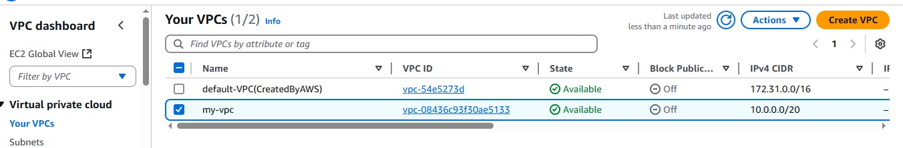

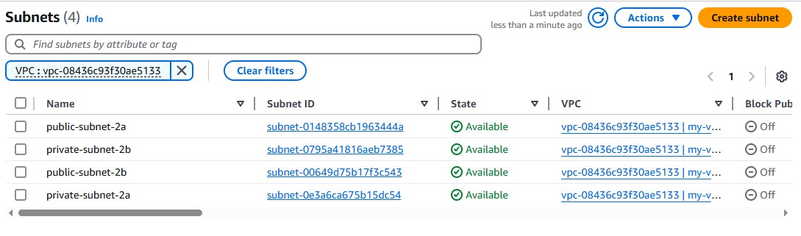
Subnets

Internet Gateway
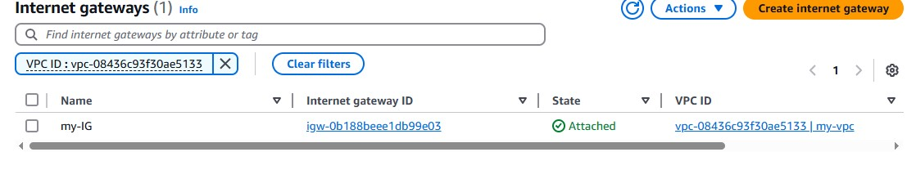

Route-Tables
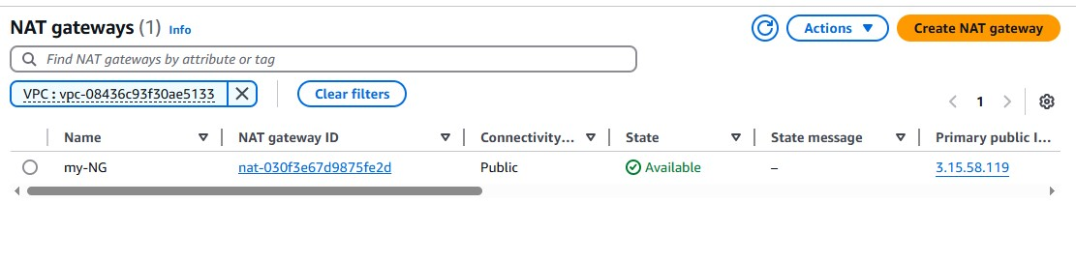
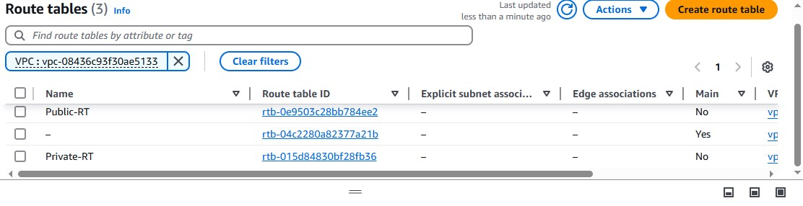
Nat-gateway

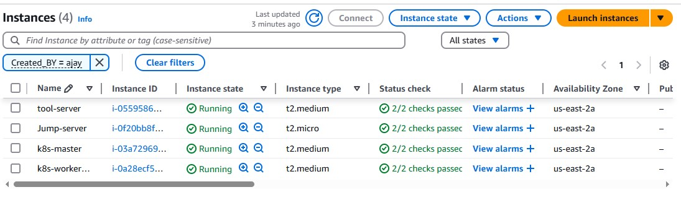
14 . Instances.

Use elasticIp:8080 for Jenkins
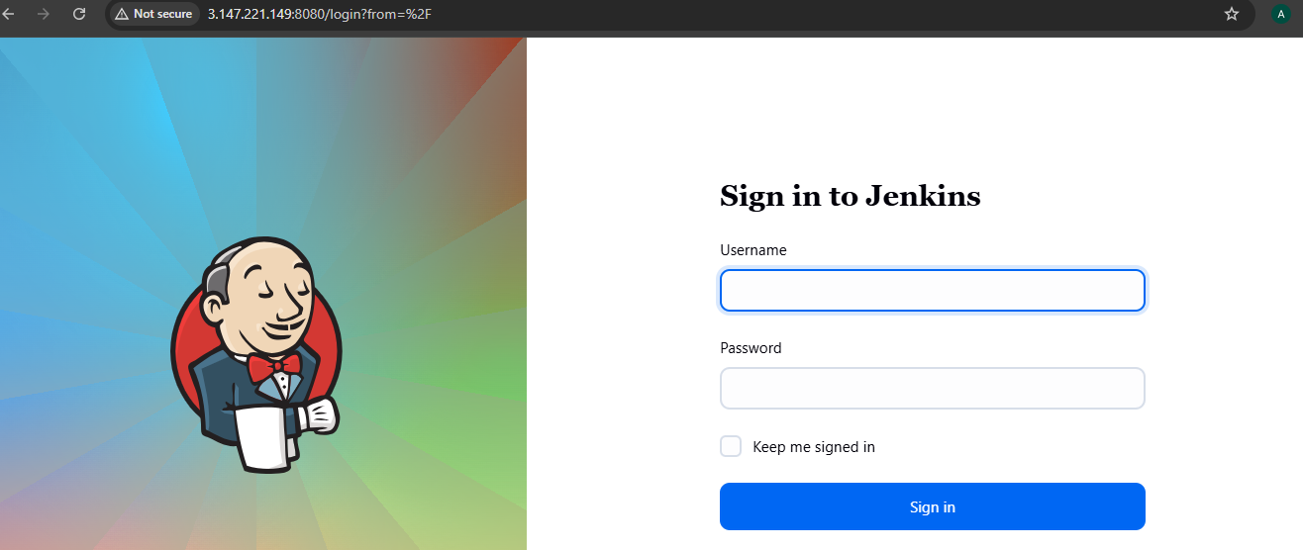

Use elastic:9000 for sonarqube
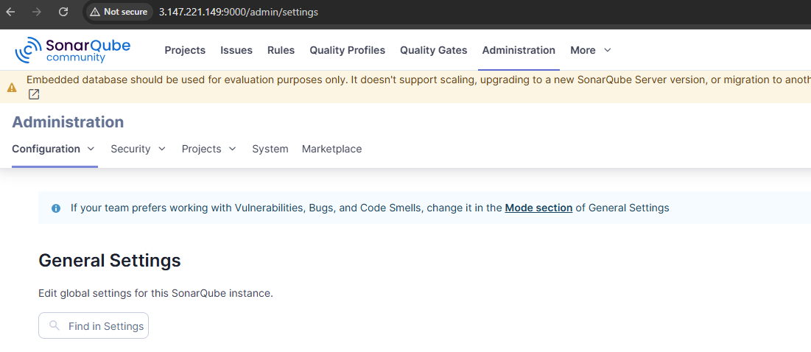

Now see the kube_join.sh whether kubeadm command is saved or not
kubeadm join 10.0.3.40:6443 --token owtaof.9wwf13y1e4ng5ee9 --discovery-token-ca-cert-hash sha256:ee5adc0e891fa18e5c8b3d9259dfa12b1a941a5a7a0bc5b14a9800690b24b592

now run this commands
terraform apply "-target=module.k8s-worker"

Ssh into k8s-master node via jump-server
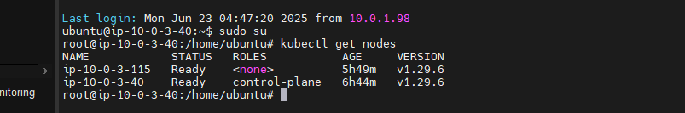
And run kubectl get nodes

K8s-worker has successfully joined master node

15 . CI/CD pipeline using Jenkins

15.1. integrating k8s with Jenkins
Install required plugins
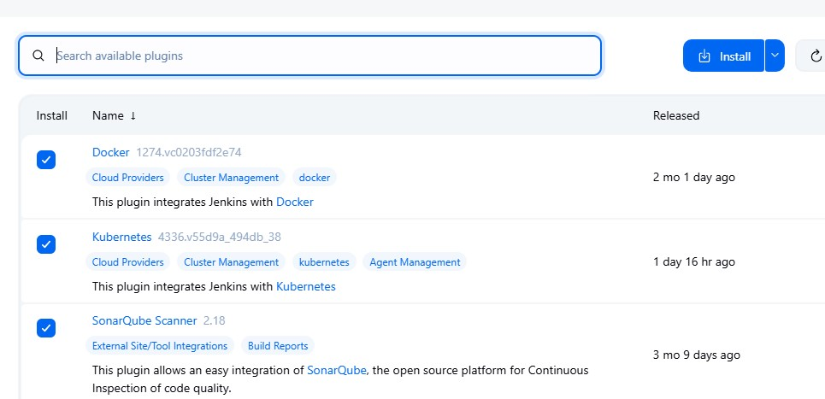

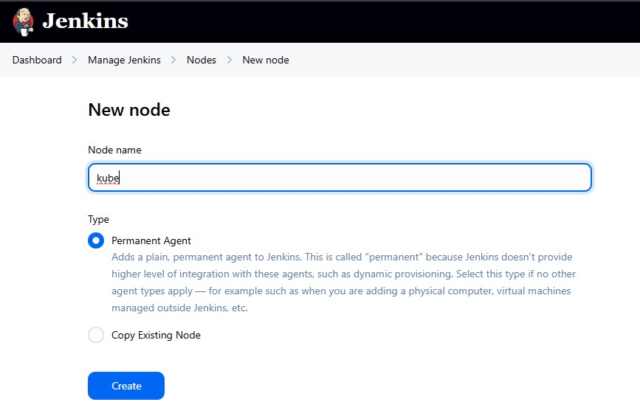
manage Jenkinsnodes give node name permanent agentcreate

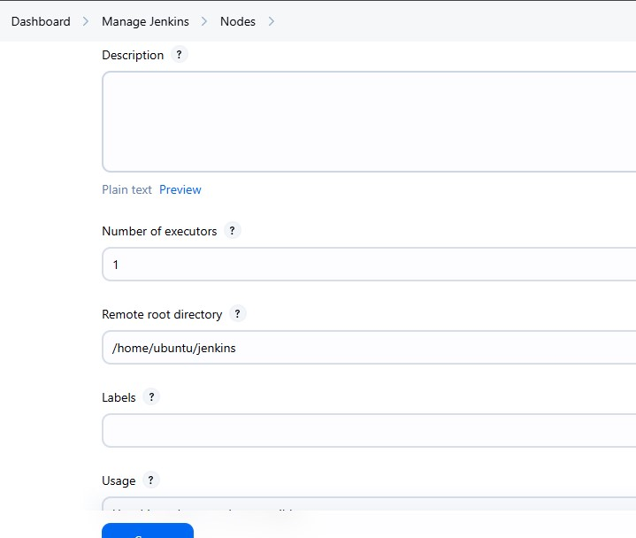
Follow next steps

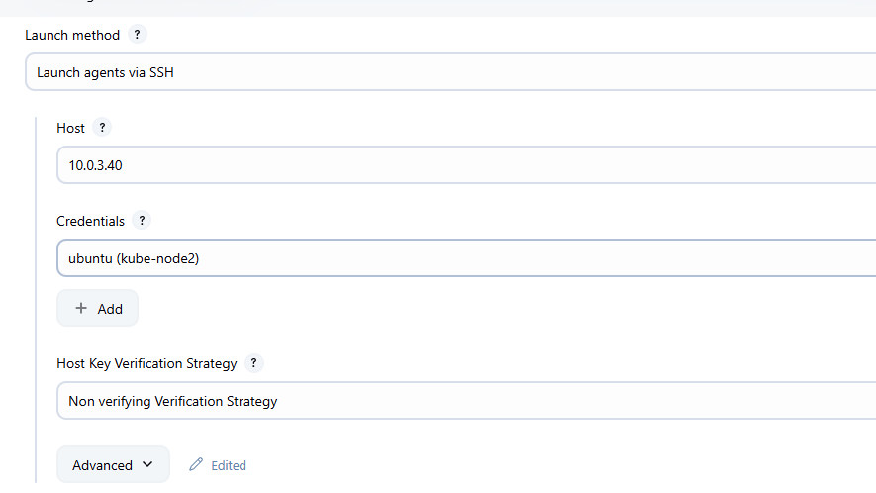

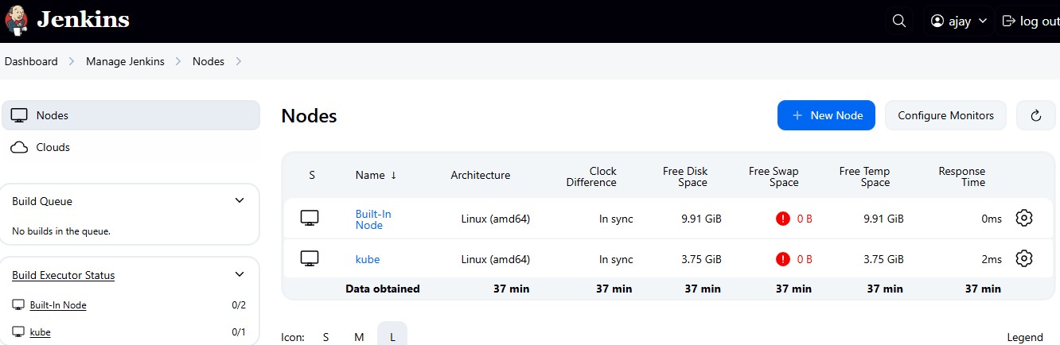
Create

15.2 Integrating Docker with Jenkins
Save dockerhub user and password in Jenkins using credentials
manage jenkinscredentialsusername and password
Save it.

15.3. Integrating jenkins sonarqube
Access sonarqube using <public-Ip>/sonarqube
administrationsecurityusertoken and create sonar-token
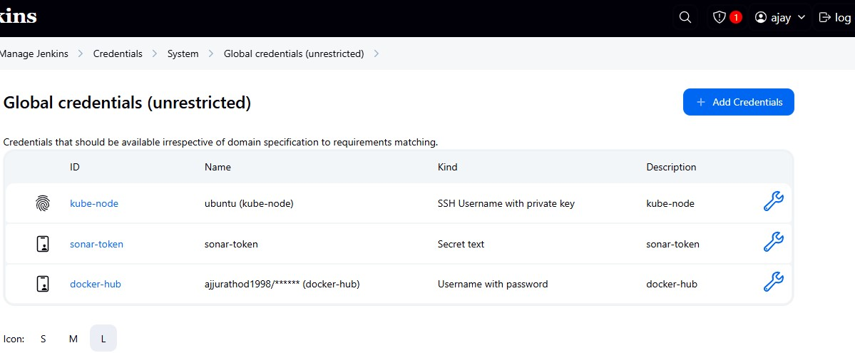
Save them in Jenkins credentials

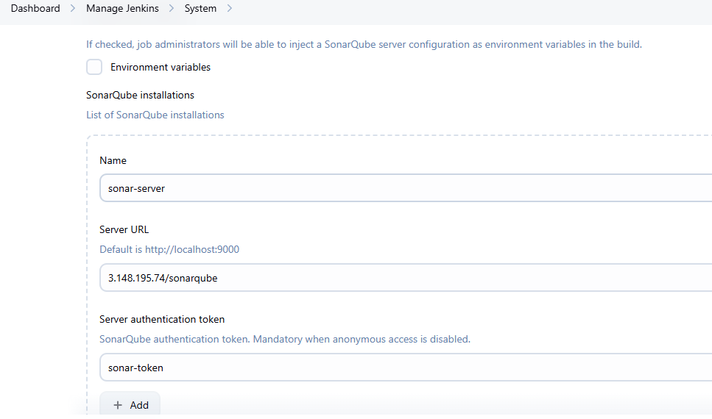
manage Jenkins system sonarqube and add sonar url

To add sonarwebhook
on sonarqube server
administrationconfigurationwebhook

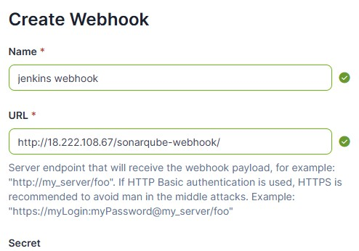

16. CI/CD pipeline
Dockerfile
# Use official Node.js LTS image
FROM node:18-alpine

# Set working directory
WORKDIR /app

# Copy package files
COPY package*.json ./

# Install dependencies RUN npm install --only=producti
RUN npm install

# Copy all source files
COPY . .

# Expose the port your app runs on
EXPOSE 3000

# Start the chatbot server
CMD ["node", "server.js"]

Deployment.yaml
apiVersion: apps/v1
kind: Deployment
metadata:
name: chatbot-deployment
labels:
app: chatbot
spec:
replicas: 4
selector:
matchLabels:
app: chatbot
template:
metadata:
name: chatbot-pod
labels:
app: chatbot
spec:
containers:
- name: chatbot-cont
image: ajjurathod1998/terraform.v:0
ports:
- containerPort: 3000

Service.yaml
apiVersion: v1
kind: Service
metadata:
name: chatbot-service
labels:
app: chatbot
spec:
selector:
app: chatbot
type: NodePort
ports:
- port: 3000
targetPort: 3000

Jenkins file
Git repo: https://github.com/ajjurathod/Chatbot-NodeJS.git
pipeline {
agent { label 'kube' }

stages {
stage('Code Checkout') {
steps {
git branch: 'master', url: "https://github.com/ajjurathod/Chatbot-NodeJS.git"
}
}

stage('NPM Install and Build') {
steps {
sh 'npm install'
sh 'npm run build'
}
}

stage('Sonar Analysis') {
steps {
script {
withSonarQubeEnv('sonar-server') {
sh '''
sonar-scanner \
-Dsonar.projectKey=terraform \
'''
}
}
}
}
stage('trivy file scan'){
steps{
sh "trivy fs --exit-code 0 --severity HIGH,CRITICAL ."

}
}
stage('dependency check'){
steps{
sh "trivy fs --exit-code 1 --vuln-type library --severity HIGH,CRITICAL ."
}
}
stage('docker image') {
steps{
sh "docker build -t ajjurathod1998/terraform.v:0 . "
}
}
stage('trivy image scan'){
steps{
sh "trivy image ajjurathod1998/terraform.v:0"
}
}
stage('push to dockerhub'){
steps{
withCredentials([usernamePassword(credentialsId: 'docker-token', passwordVariable: 'passwordVariable', usernameVariable: 'usernameVariable')]) {
sh " echo $passwordVariable | docker login -u $usernameVariable --password-stdin"
sh "docker push ajjurathod1998/terraform.v:0"
}
}
}
stage('deploying application '){
steps{
sh "kubectl apply -f deployment.yaml"
sh "kubectl apply -f service.yaml"
}
}
}
}

outputs
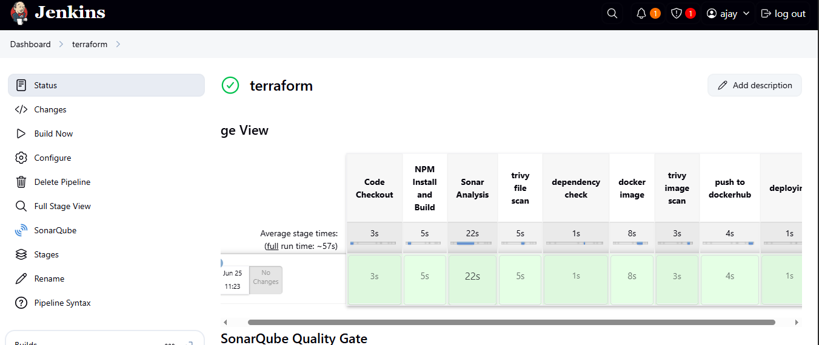
Sonarqube
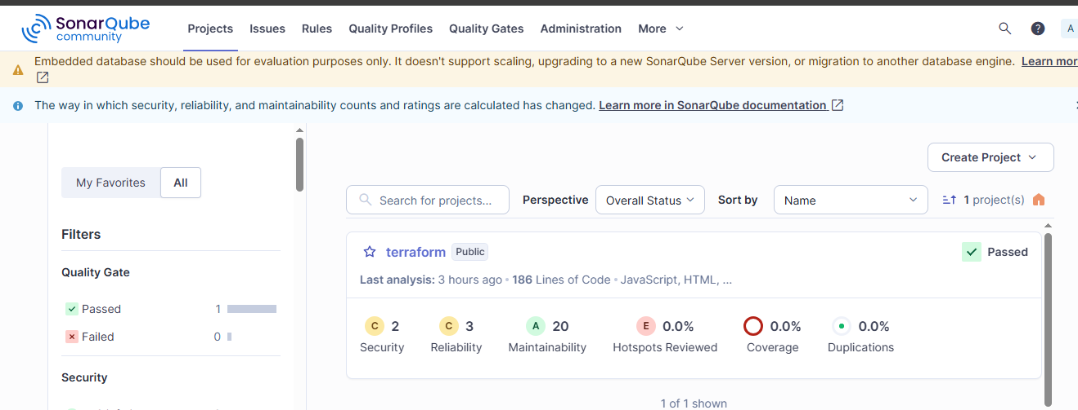

Trivy file scan
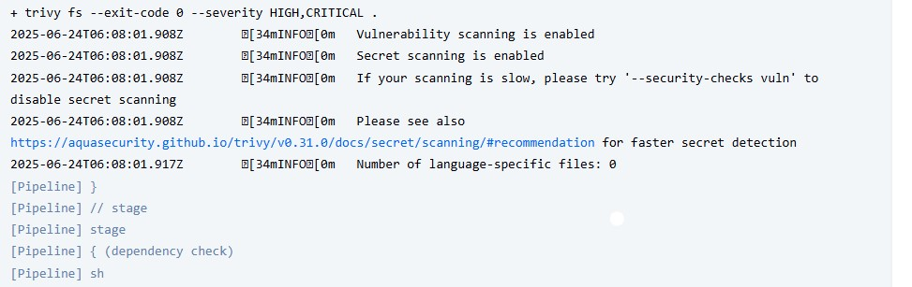

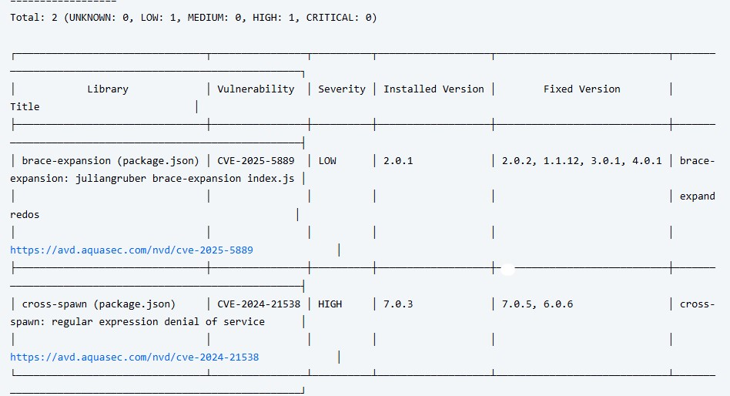
Dependency checks
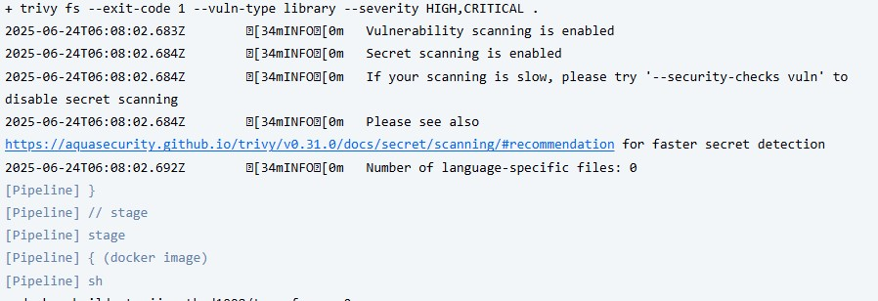

Image build
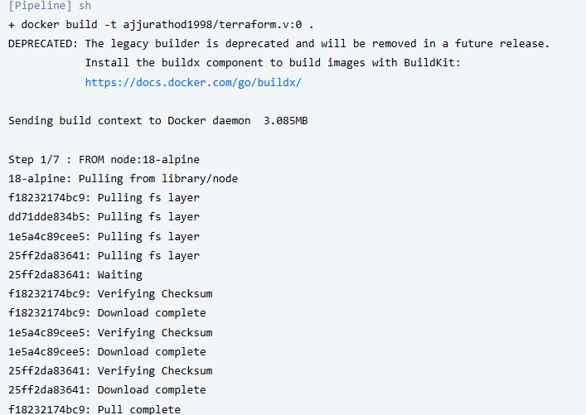
Image scan
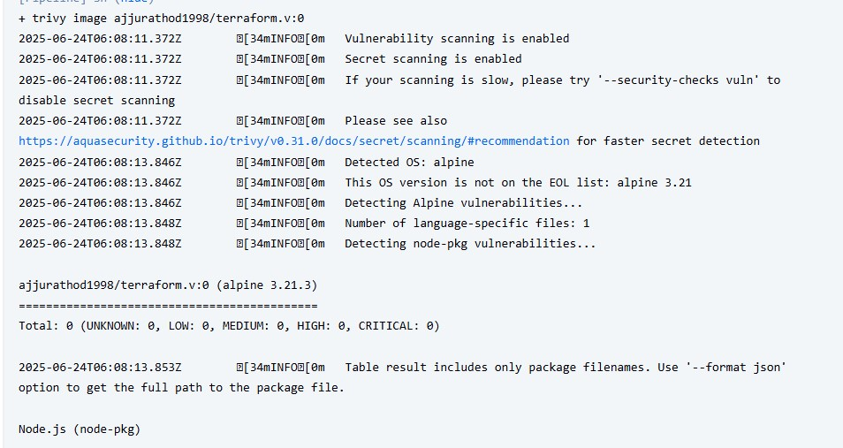
Deployment stage
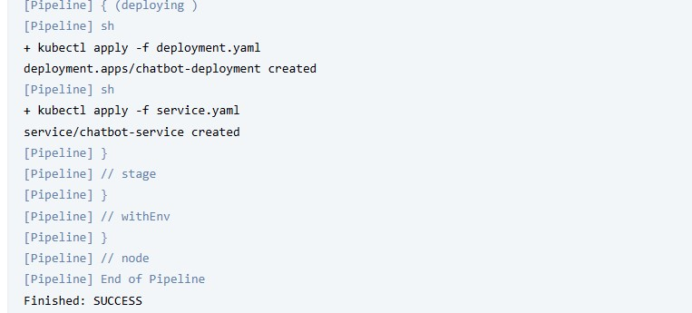

17. Autoscaling group
Tester-instaance from which AMI is created
Just launch an empty instance without configuring anything and create image of it
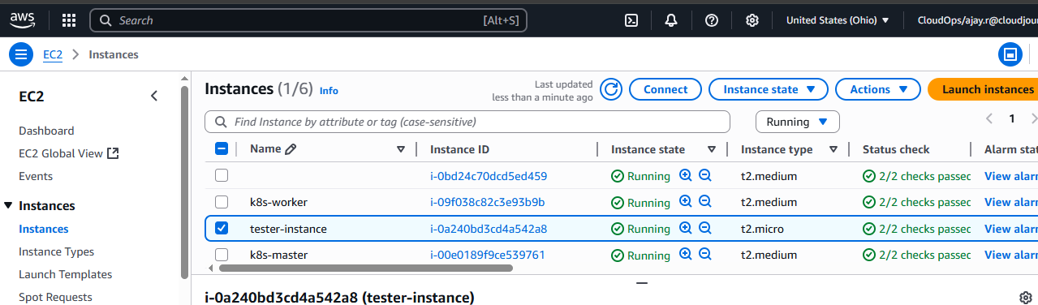

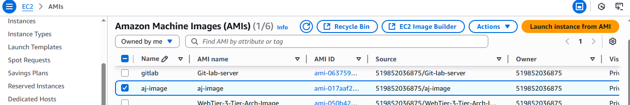

From using this image launch template and remember to add worker node userdata in user_data
This will new instance to join cluster automatically
user_data = "C:/Terraform/terraform-main-project/worker_userdata.sh"

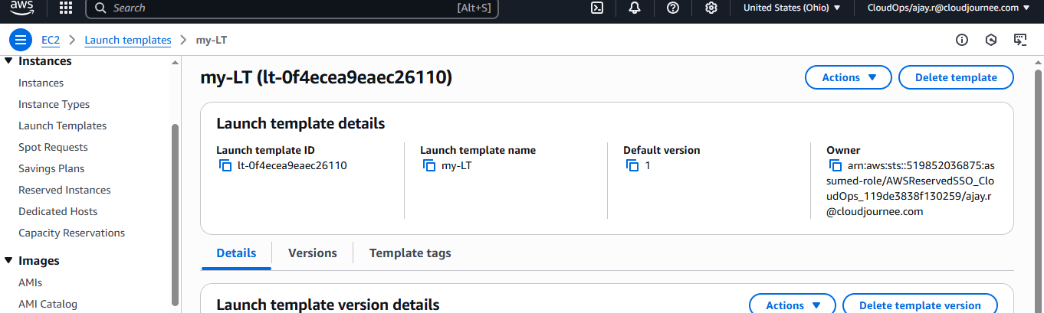

By using this create Autoscaling group
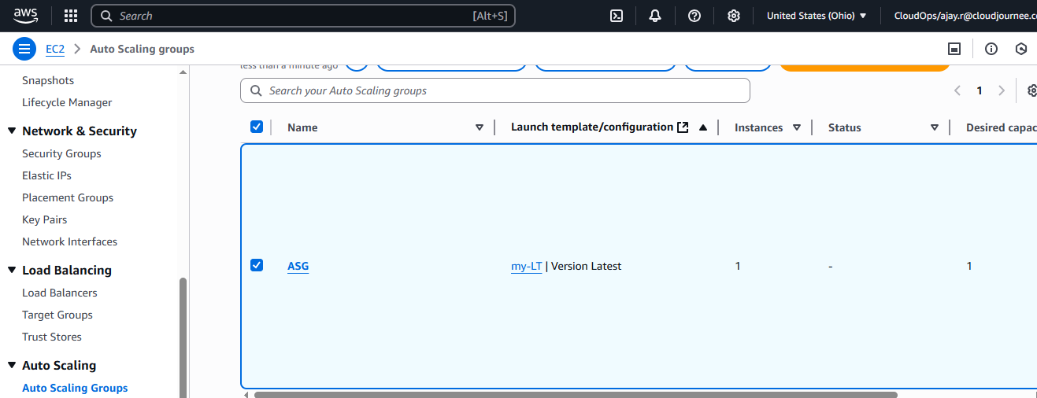

18. Load balancer
Target group
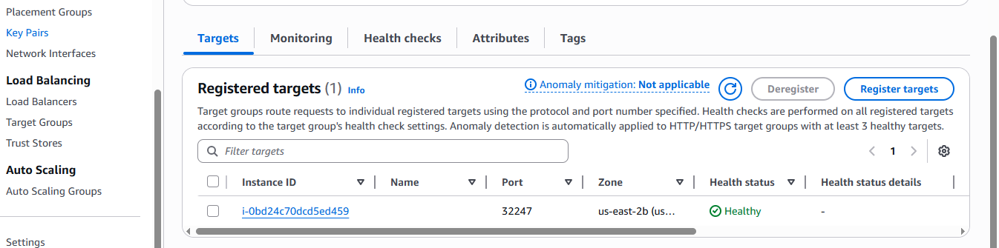

Load balancer
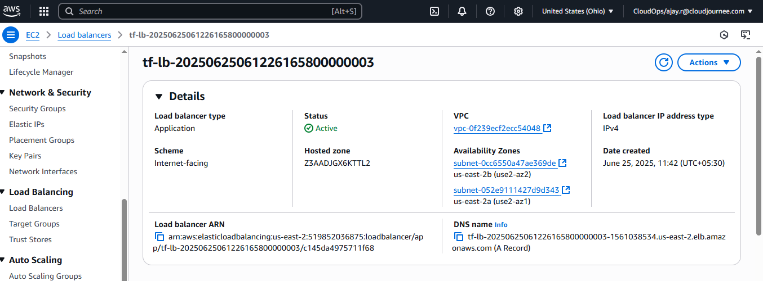

19. Access chatbot application on Browser
